

Enterprise Systems and Architecture

Continuous Assessment

Assignment 2



DT282

BSc in Computer Science

(International)

**Jake Young**

**C14706715**

**DT282/4**

**Due Date: 29/04/2018**

# Table of Contents:

Table of Contents: 2

Table of Figures: 2

Essay 3

Bibliography: 12

# Table of Figures:

**Figure A – Diagram of the Cloud Computing Model 3**

**Figure B – Image of ERP 8**

**Figure C – Image of SCM 9**

**Figure D – Image of CRM 10**

# 

# Essay

A large percentage of organisations utilise some form of cloud computing model. In terms of Enterprise Systems such as ERP’s, SCM’s and CRM’s and the functionality they provide, what can an organisation expect to have available to them through these models, how does it provide advantages over ‘in-house’ implementations and what are the particular issues and risks involved in moving to cloud delivered business systems.

Cloud computing is the ability to store and access data and different programs over the internet. Storing data over the internet is known as storing on the cloud. This is a relatively new way of data storage compared to the more traditional method which was, storing data on your computer system. Therefore, cloud computing doesn’t mean storing data physically in a cloud, it is more of a metaphor for storing data on the internet.

“If someone asks me what cloud computing is, I try not to get bogged down with definitions. I tell them that, simply put, cloud computing is a better way to run your business”

(Marc Benioff, Founder, CEO and Chairman of Salesforce)

Since cloud computing is a relatively new topic of conversation which is not yet fully discovered nor is it completely understood by all, this means the cloud computing doesn’t yet have one set model. It is still up for interpretation. All of the cloud computing models can be mapped with three specific layers; Infrastructure Cloud, Platform Cloud, and Application Cloud.

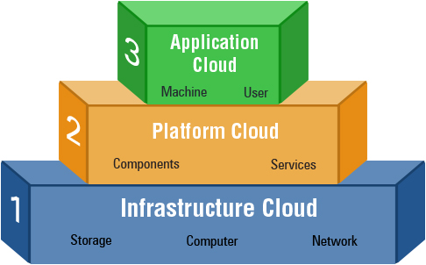

Figure A – Diagram of the Cloud Computing Model

The infrastructure cloud which is also known as IaaS. This stands for Infrastructure as a Service. This cloud provides the storage facility for the cloud. It is also responsible for dispersal of the cloud’s resources as a service for use by developers. IaaS is used by many enterprises as it eliminates the headache of having to setup data centres to hold the enterprises data. IaaS is a great way of adding value to and enterprise through capital saving, scalability, privacy, and reliability.

Infrastructure as a Service (IaaS) comes with the following characteristics:

* Resources distributed as a service
* Dynamic ability to scale resources
* Concurrent users on a single piece of hardware

Infrastructure as a Service (IaaS) comes with many advantages in terms of its effect on the organisation such as the following:

* The organisation is responsible for the maintenance of the software.

Since this cloud platform only provides the infrastructure, it is solely up to the organisation to take care of the maintenance and upgrading of the software developed.

* This layer allows for various different pricing models. Since a lot of great software is quite costly, this layer allows for payment of what the users use only.

This method allows users or start-up businesses to use strong software which before would have been an unobtainable option due to capital restrictions.

* The Infrastructure as a Service (IaaS) may give the business better security measures which are probably more secure than the businesses original security measures.

“In-House” security is nearly always less secure and not as up to date as the IaaS security. Therefore, for the most part, it is better to go with the Infrastructure as a Service (IaaS) security measures instead.

The second layer of the cloud computing model which is also the middle layer is known as the Platform as a Service layer, which has a shorthand version known as PaaS. Platform as a Service (PaaS) delivers environments for developing and operating as a service. This middle layer includes many tools and services created to assist developers in coding and deploying their application in a quick turn around and efficient way. This layer has a main responsibility of development and deployment of software only, which will be created over the web. An example of this layer being utilized in a business may be SalesForce.

Similarly, to Infrastructure as a Service (IaaS), Platform as a Service (PaaS) also comes with its own unique characteristics for its layer which are the following:

* Individual environment to do development, testing and deployment of applications
* Web-based user interface design tools to create, test, and deploy different scenarios
* OS and cloud programming API’s to create application which are cloud ready

Platform as a Service (PaaS) is very similar to Infrastructure as a Service (IaaS) in the sense that they have very similar advantages such as the following:

* Platform as a Service (PaaS) allows for the option to develop on multiple platforms such a mobile, browser, etc.

This service will attract organisations who are seeking multi-platform development

* The Platform as a Service (PaaS) cloud provider organises development of projects.

The Platform as a Service (PaaS) cloud provider manages the release of software.

* The Platform as a Service (PaaS) cloud provider takes care of a lot of the backend elements of a project.

The cloud provider will manage the servers, the data centres, and will also take care of managing and backing up all of the organisations data.

The last layer of the cloud computing model which is the top layer of the model is the Software as a Service layer. Similarly, to the Platform as a Service (PaaS), Software as a Service (SaaS)is also a very functional layer. This type of cloud acts almost like a server in the sense that this cloud delivers an application through the browser to multiple users. This is done through using a multitenant architecture. In Software as a Service (SaaS), the application owner rents out his licence to use the application on a subscription basis or a certain period of time to consumers. Since there is only one application running, the costing of using this type of cloud is pretty low. An example of the Software as a Service (SaaS) may be SRM, or ERP.

Some of the characteristics of Software as a Service includes the following;

* Main application which is web-based, which is release to users on a subscription basis
* No issues regarding software upgrading or maintenance as they are taking care of by the service provider
* API’s allow for integration between different applications

Software as a Service (SaaS) is a service which also carries similar advantages to Platform as a Service (PaaS) and Infrastructure as a Service (IaaS) such as the following:

* Software as a Service (SaaS) provides a low-cost service.

When using Software as a Service (SaaS), you will only pay for what you use as it works off a usage basis instead of a set payment basis.

* Software as a Service (SaaS) provides rapid turnaround times and quick prototyping.

Many Software as a Service companies decide to release their product as a trial version. This version will allow for the product to be tried and tested by many users on an international scale.

* Software as a Service (SaaS) is very much user-friendly.

Since Software as a Service (SaaS) is used on familiar web browsers, it tends to become quite easy for users to grasp and adapt to.

Deciding on using a cloud-based environment like any of the above I discussed about, Platform as a Service (PaaS), Infrastructure as a Service (IaaS), or System as a Service (SaaS) versus an in-house environment can be a difficult and quite costly decision for any business.

Both sides come with their own set of benefits and risks.

Security is a fact which needs to be considered when deciding on the type of environment which would best suit your company. Depending on the type of business it is, the decision on environment type will be influenced accordingly. For the case of a bank or an insurance company, usually these organisations would use an in-house environment as it will ensure the security of their customer’s identity is left secure at all times and unbreechable.

Cloud environments also have very good security measures put in place but sometimes are not at such a high-level compared to in-house environments such as an in-house banking security environment.

Data ownership is another big fact to consider when weighing up the environment. With in-house environments, the ownership of the data is pretty clear, it is the organisations sole responsibility. Whereas, cloud-based environments take the responsibility. These cloud-based environments have strong mechanisms put in place in order to track and protect their users’ data with confidence.

Data on a cloud-based environment can only be accessed by the organisation, it isn’t possible to access the data if you are an unauthorized user.

Another are which cloud-based environment trumps over in-house environments is performance and availability. Like all environments, there are risks involved that the system may shutdown or fail for a period of time. Cloud-based environments have a rapid response time and can usually fix errors in a faster time than in-house environments.

All organisations require some shape or form of support. Thankfully cloud-based environments are there to provide great support for their users. Depending on the type of support required, cloud-based environments are available to cater for the different types of support such as human interaction, software support, etc. Usually cloud-based support are based online via one-to-one conversations, tutorials, online help desks, etc.

Finally, the last fact which needs to be considered when deciding on the type of environment which best suits your organisation is usability. Good usability ensures great user experience. It is arguably the most important factor to consider. The system should be easy to use, familiar to users, and quite straightforward. If a system is not relatively easy to use, ten chances to one, it will not reach a high success rate. Users today are not looking for systems which require extensive prior knowledge. Users want to use systems which are simple to follow and use. Through the use of online tutorials and demonstrations, cloud-based environments ensure their systems are as easy to follow as possible.

An enterprise system is essentially the overall combination of computer hardware and software that an enterprise uses to run their overall operation of their business. Many enterprise systems are responsible for handling the large volumes of data which a business owns.

“Enterprise systems are software applications that have cross-organizational capabilities as opposed to department or group-specific programs. They allow for collaboration and communication across the organization through collection of data that is accessible and usable by multiple departments”

(www.techwalla.com)

There are many different types of enterprise systems such as ERP’s, SCM’s, and CRM’s. All of these systems are unique in the sense that they all have different operations that they perform.

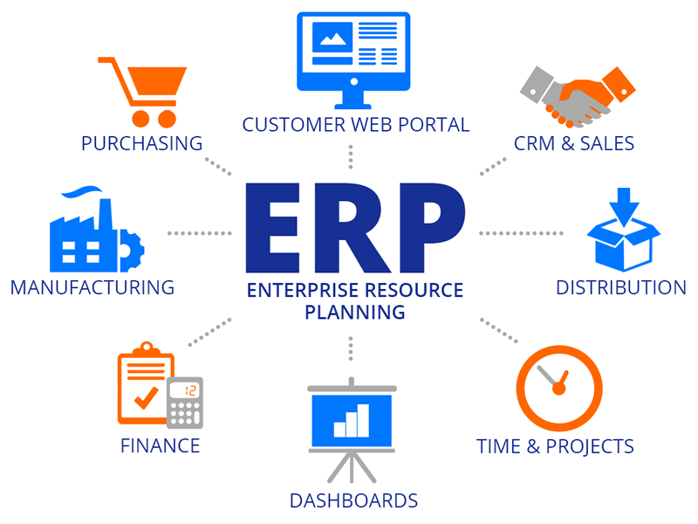

Figure B – Image of ERP

ERP stands for Enterprise Resource Planning. This type of enterprise software is responsible for the systems software packages which are used by the organisations to manage the businesses on a daily basis. Some of the tasks an Enterprise Resource Planning system (ERP) may be responsible for may be taking care of the project management side of a business, manufacturing, and accounting. Enterprise Resource Planning (ERP) are responsible also for interconnecting different process’ from within a business, which will allow smooth running of a business. Enterprise Resource Planning (ERP) are invaluable as they can manage large sums of data and filter through that data in order to remove duplicated data. This ensure the data’s integrity is less secured. Enterprise Resource Planning (ERP) are available for enterprises of all sizes.

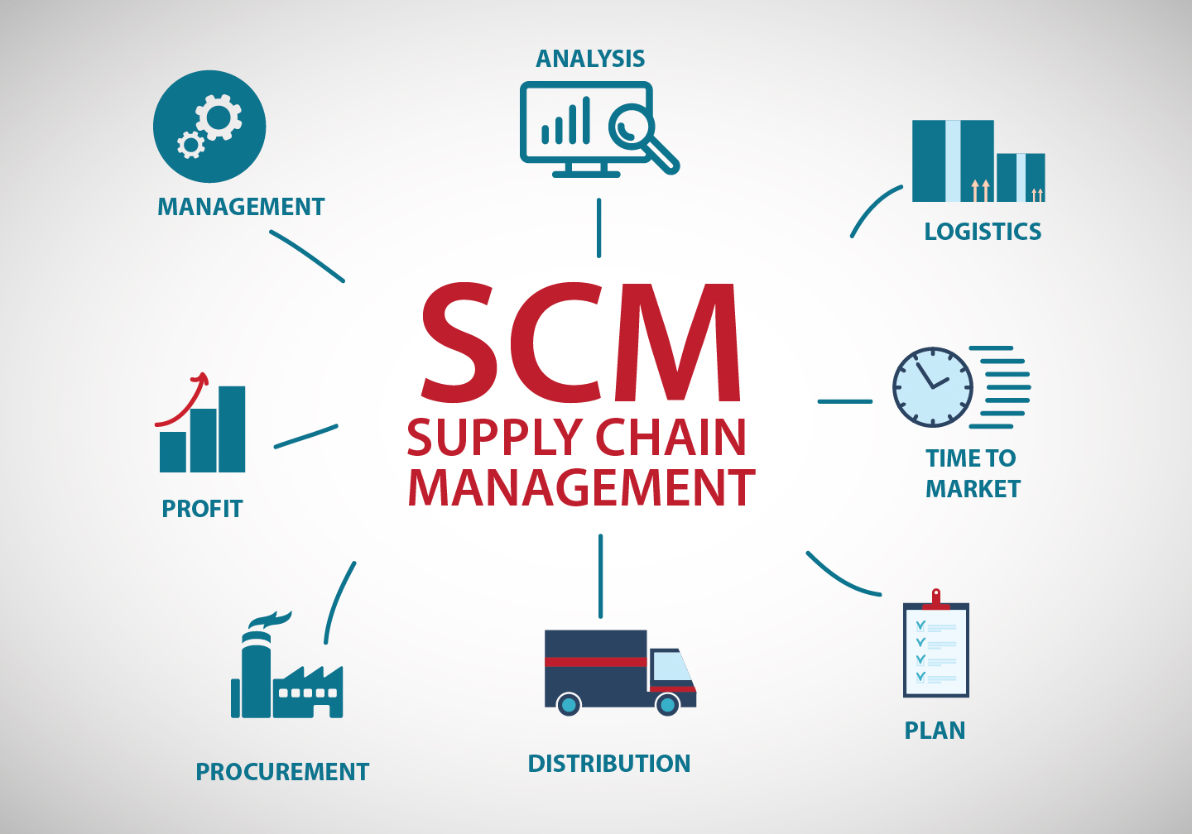

Figure C – Image of SCM

SCM’s are another type of enterprise system. SCM stands for Supply Chain Management. A supply chain refers to a list of tasks, data, people, or resources, etc. The management of the supply chain is in charge of all activities within the supply chain. Some of these activities may include the supply development, sourcing supplies, production of supplies, and strategy planning. The management of a supply chain ensures that the supply is being correctly managed by in terms of manufacturing, transporting, and selling of supplies.

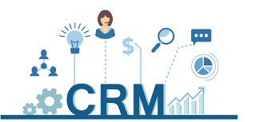

Figure D – Image of CRM

The other type of enterprise system is the Customer Relationship Management system (CRM). This type of system was developed in order to attempt to develop a relationship in the sales department with the customers. The use of Customer Relationship Management (CRM) ensured the sales department had a better and clearer understanding of the customer and the customer’s needs and wants. Through gathering this information, the sales team can market this gathered information in order to better market the business. Customer Relationship Management (CRM) doesn’t only work on relationships, it also works on the integration of the system with other systems. Customer Relationship Management (CRM) allows the sales process flow which greatly improves the employee productivity.

Even though having a system work off a cloud based system is great as it makes the system more available, there are always going to be integration issues involved.

The most prominent challenge an organisation has to overcome when integrating their system to a cloud-delivered system is security. Cloud Enterprise Resource Planning systems (ERP) are open to a security threat. Having to share resources online over the cloud can lead to risks in terms of performance. Many organisations do not feel comfortable having their sensitive data a little more open to threats than wat it originally is. However, the cloud computing models are very secure and tend to have a high level of security put in place.

Another issue which deter organisations from moving their system to a cloud-based system is down to performance risks. Since the system is cloud-base which is online, this means a strong internet connection is essential when using the online system. Network failures on the cloud-based system may result in significant loss of data.

Customisation is an issue which always needs to be resolved before integrating a system to a cloud-based system. Many organisations do not like to follow the term “Cookie Cutter”. This means that since they are following a standard cloud-based system, this system comes with a set way tasks are done and a set way the system is laid out. Organisations, prefer to put their own stamp on things, they would prefer their organisation to be unique and have their own unique system. This is one issue which severely limits organisations.

Another issue which needs to be resolved is the loss of employees. Since a company is moving their system to a cloud-based system, it is no longer a requirement to have an IT department as all of the IT work will be done through the online system. This results in a significant loss of staff and possibly staff morale within the company.

Therefore, as you can there are a lot of pros and cons of moving a system to a cloud-delivered system. Nearly all organisations in today’s environment have already integrated into their organisation some form or cloud computing. This is mainly down to the ever changes world around whom which are moving more and more towards a technologically savvy world. Depending on your organisation and your organisations functionality, the choice between in-house and a cloud delivered system will vary greatly. This decision should never be taken lightly. However, I do believe in order progress your organisation towards a more prosperous future, it is very important to move your organisation towards a cloud-delivered system.

“There are still companies who attach tremendous risk to this technology migration. Ultimately, however, I believe that these more conservative enterprises will find many of their fears unfounded and offset by the profitable and expansive future that the cloud represents”

(www.enterprisetech.com)

# Bibliography:

1. *"All-in-One CRM." Crm. Accessed April 11, 2018. http://www.agilecrm.com/.*
2. *Barry, Douglas K. "Web Services, Service-Oriented Architectures, and Cloud Computing." Service Architecture. Accessed April 11, 2018. http://www.service-architecture.com/.*
3. *"Become the Company Your Customers Love to Order from." Handshake | B2B Commerce Platform. Accessed April 11, 2018. http://www.handshake.com/.*
4. *"Enterprise Mobile DevOps Platform." Bitbar. Accessed April 11, 2018. http://www.bitbar.com/.*
5. *"Java Development Philippines - Java Developers - Manila | Ideyatech." Java Development Philippines - Java Developers - Manila | Ideyatech. Accessed April 11, 2018. http://www.ideyatech.com/.*
6. *"Online Business Dictionary - BusinessDictionary.com." Online Business Dictionary - BusinessDictionary.com. Accessed April 11, 2018. http://www.businessdictionary.com/.*
7. *"Paranet Solutions." Paranet Solutions. Accessed April 11, 2018. http://www.paranet.com/.*
8. *"Software Development Company - Software Outsourcing Company India | Tatvasoft." TatvaSoft - Software Development Company. Accessed April 11, 2018. http://www.tatvasoft.com/.*